**Deliverable 1**

Jingzhu Guo

Duy Huynh

Ian McPeek

Putthida Samrith

April 20, 2015

**User Stories**

**Park manager:**

1. As a park manager, I want to log-in so that I can manage my jobs.
2. As a park manager, I want to create a park job so that volunteers can sign up.
3. As a park manager, I want to view a park job so that I can manage that job .
4. As a park manager, I want to edit a park job so that job details are up-to-date.
5. As a park manager, I want to view the list of volunteers for a given job so that I know who will be volunteering.
6. As a park manager, I want to cancel a park job so volunteers can’t sign-up.
7. As a park manager, I want to grade a park job by intensity levels so volunteers know the labor requirements.
8. As a park manager, I want to edit a completed job with information about how it went so that I can plan better for future jobs.
9. As a park manager, I want to flag volunteers as a “no-show” who did not show up so that they can be restricted from signing up for future jobs.
10. As a park manager, I want to report a volunteer’s “bad” behavior so that staff can review their future volunteer eligibility.

**Volunteer:**

1. As a volunteer, I want to log-in so that I can manage my account.
2. As a volunteer, I want to sign-up for a park job so that I can volunteer.
3. As a volunteer, I want to cancel my sign-up for a park job so that park managers can adjust accordingly.
4. As a volunteer, I want to view if a job has been cancelled so that I don’t try signing up.
5. As a volunteer, I want to find park jobs by location so that I can sign-up.
6. As a volunteer, I want to find park jobs by park name so that I can sign-up.
7. As a volunteer, I want to find park jobs by city name so that I can sign-up.
8. As a volunteer, I want to find park jobs by zip code so that I can sign-up.
9. As a volunteer, I want to view current volunteer capacity for a park job, so that I can check for any openings.
10. As a volunteer, I want to see the current park jobs that I have signed up for so that I can plan on attending the job.
11. As a volunteer, I want to view past jobs that I have signed up for so that I can pat myself on the back.
12. As a volunteer, I want to edit my contact information so that I can be contacted
13. As a volunteer, I want to view details about job, so I know what to expect.

**Office staff:**

1. As office staff, I want to approve a job before it is posted onto the website so that volunteers can view it.
2. As office staff, I want to log-in so that I can manage park jobs.
3. As office staff, I want to cancel a park job so that volunteers can’t sign-up.
4. As office staff, I want to edit volunteer contact info so they can be contacted in the future.
5. As office staff, I want to create a park job so that volunteers can sign up.
6. As office staff, I want to edit a park job so that job details are up-to-date.
7. As office staff, I want to blackball a volunteer so that they are unable to sign-up for future park jobs.
8. As office staff, I want to look at the calendar of pending jobs so I do not have to be in the office.
9. As office staff, I want to view a volunteer’s job history so that I can see how many jobs they have been to.
10. As office staff, I want to view a volunteer’s no-show/cancellation history so that I can evaluate their eligibility to volunteer to future jobs.
11. As office staff, I want to see all past jobs organized by park district so that I can quickly find a park job.
12. As office staff, I want to generate a report on jobs and volunteers to evaluate the success of the system.
13. As office staff, I want to scale the maximum number of jobs so that we don’t exhaust our resources.
14. As office staff, I want to view the report the park manager wrote about a completed job so that I can better manage future ones.

**Business Rules**

1. Website must indicate canceled park jobs.
2. Jobs must not be scheduled more than [3] months into the future.
3. There can only be a maximum of [30] pending jobs.
4. There can only be [5] maximum jobs for any given week.
5. Volunteers cannot sign-up for more than one job for a specific date.
6. Jobs at the same park must not be scheduled on the same date.
7. Maximum job length is [2] days.
8. Volunteers must not be allowed to sign-up for past jobs.
9. Underage volunteers must be notified that parents must sign waiver on-site.
10. Volunteers must be informed when jobs are cancelled.
11. Parks managers and office staff must be notified if the job doesn’t meet [75%] of volunteer quota [48] hours before job.
12. Volunteers must have an email address to sign-up for a job.
13. Volunteers are reminded of park job commitments [2] days in advance.
14. Jobs must be graded by a coarse scale of light, medium, and heavy.
15. The number of volunteers must be within the range of 5 to 30 per job.
16. A blackballed volunteer must contact office staff when trying to sign up for a job.
17. Jobs are allowed to happen during weekdays and holidays.
18. Volunteers cannot view unpublished jobs.

**Paper Prototypes**

**As a park manager, I want to submit a job so that people can volunteer.**

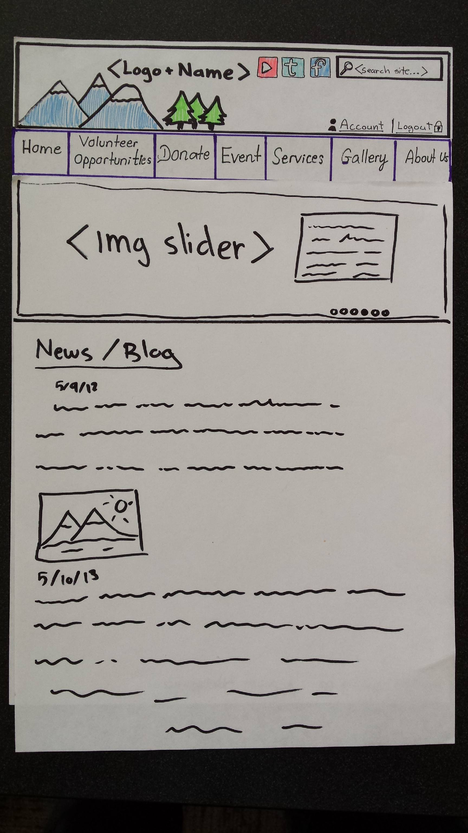

Figure 1

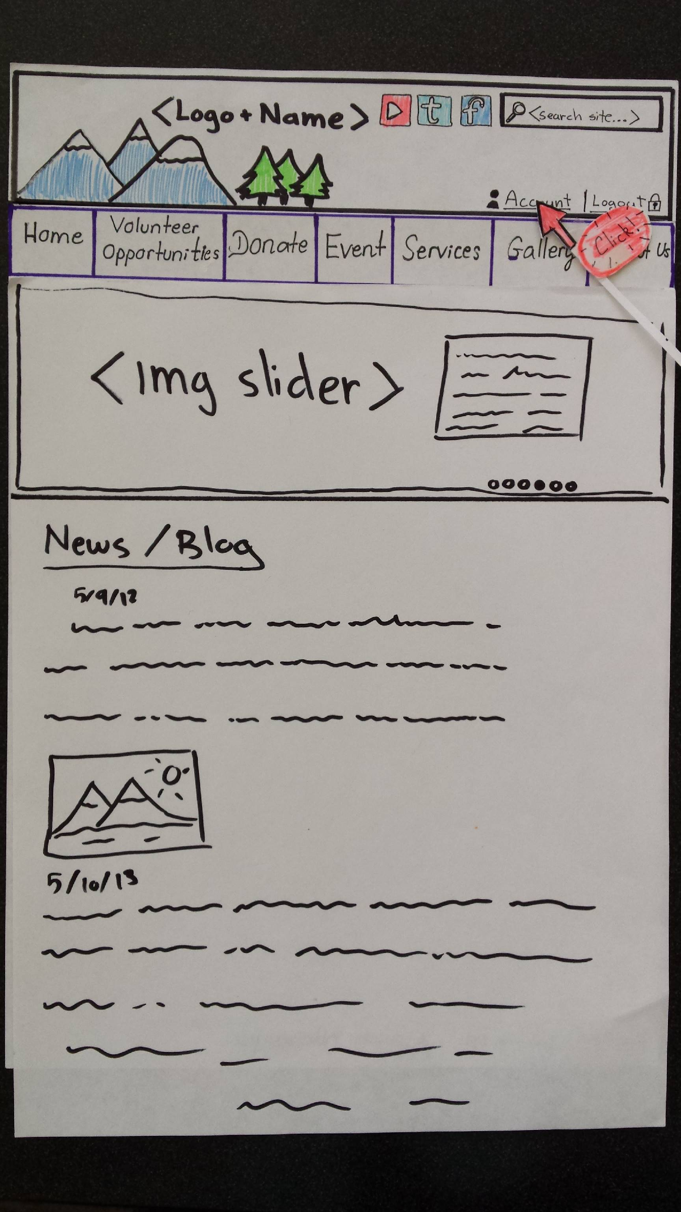

Figure 2

Figure 3

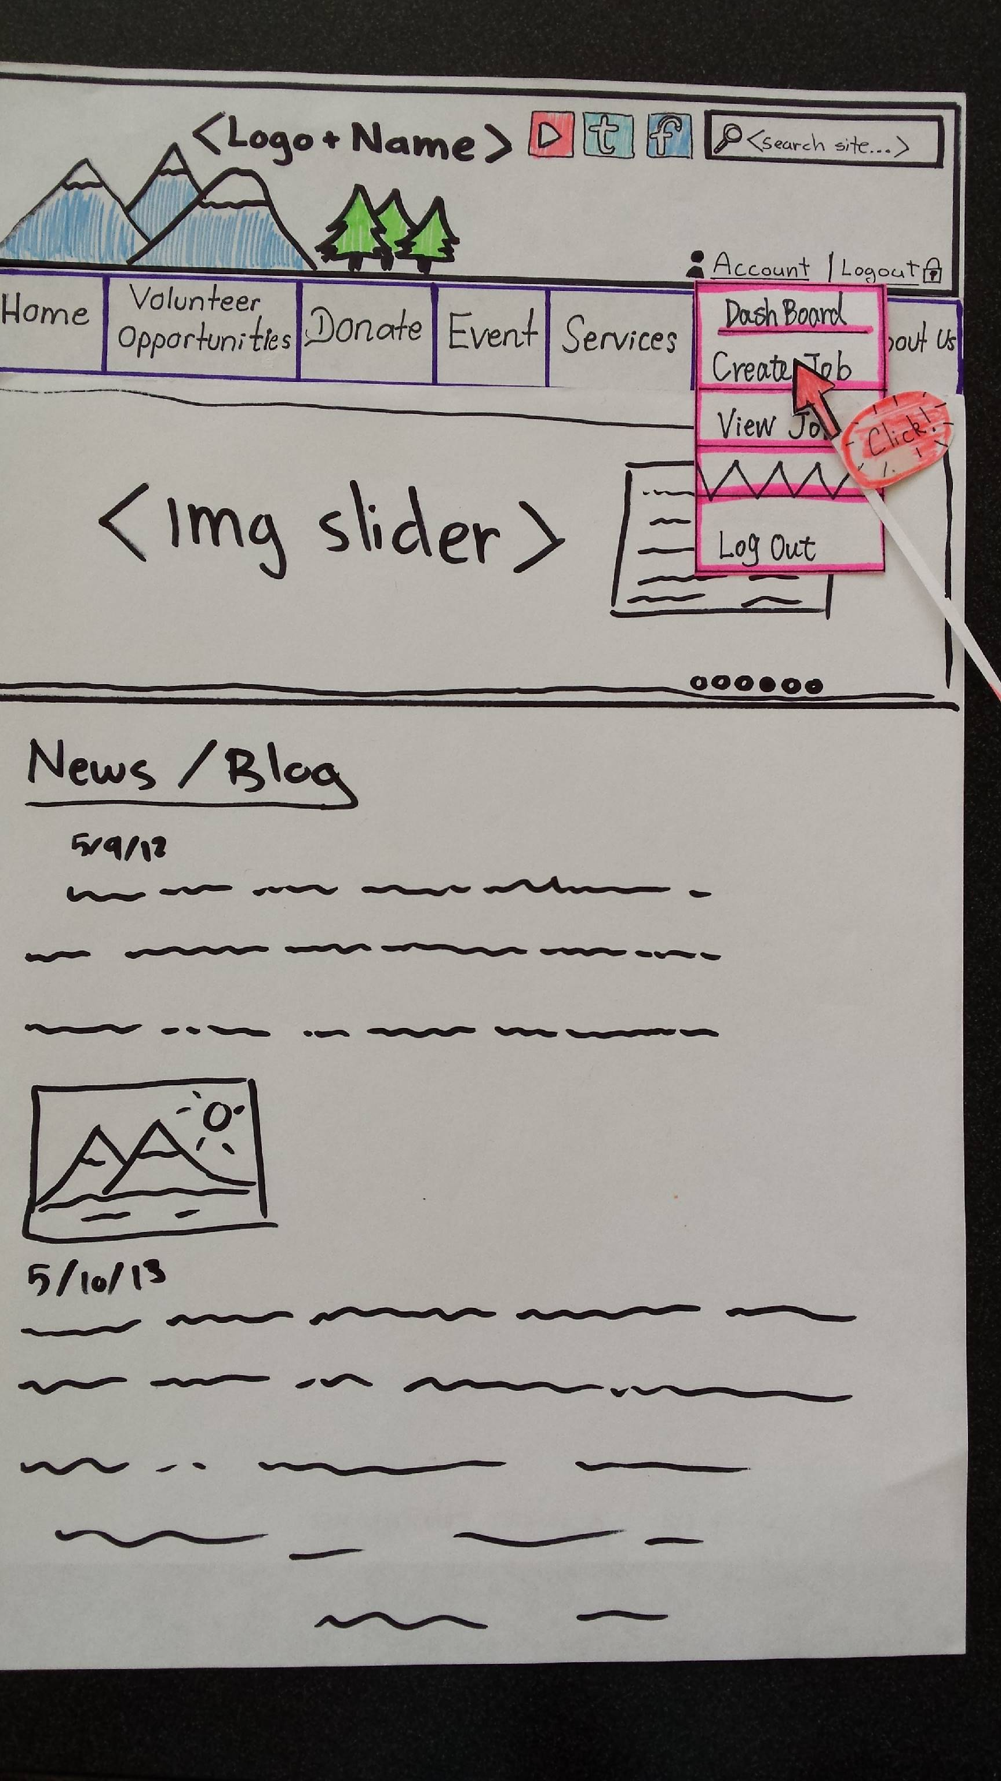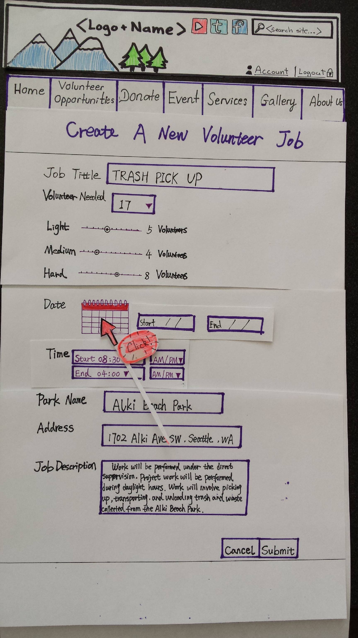

Figure 4

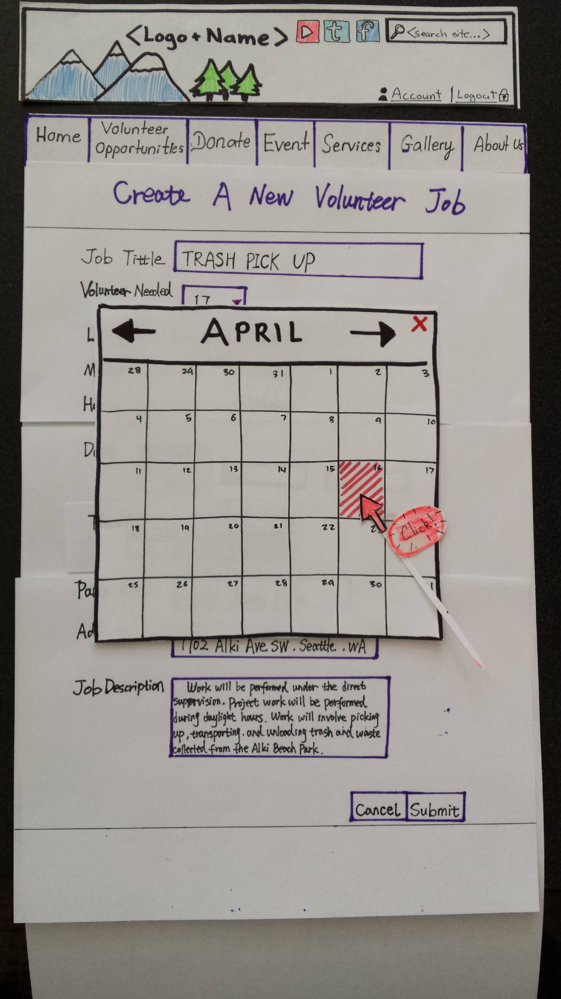

Figure 5

Figure 6

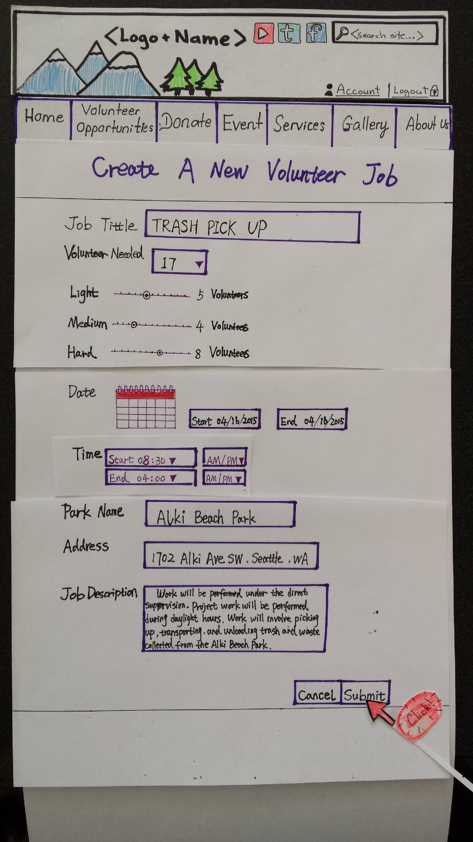

Figure 7

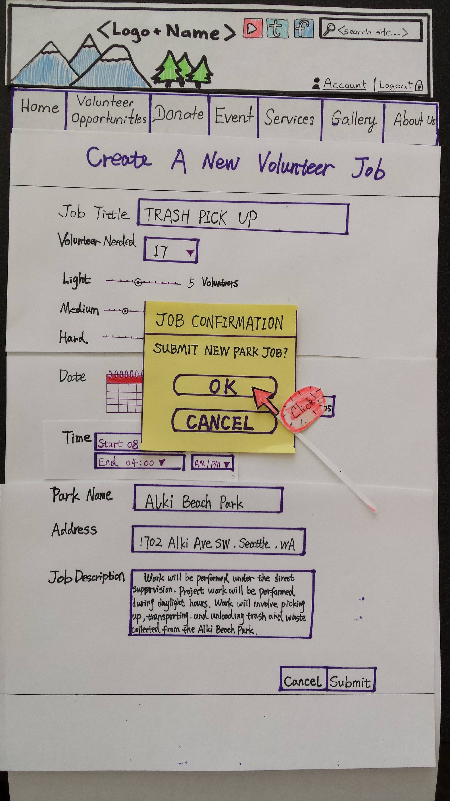

**As a volunteer, I want to view available jobs so that I can sign up for a job.**

Figure 8

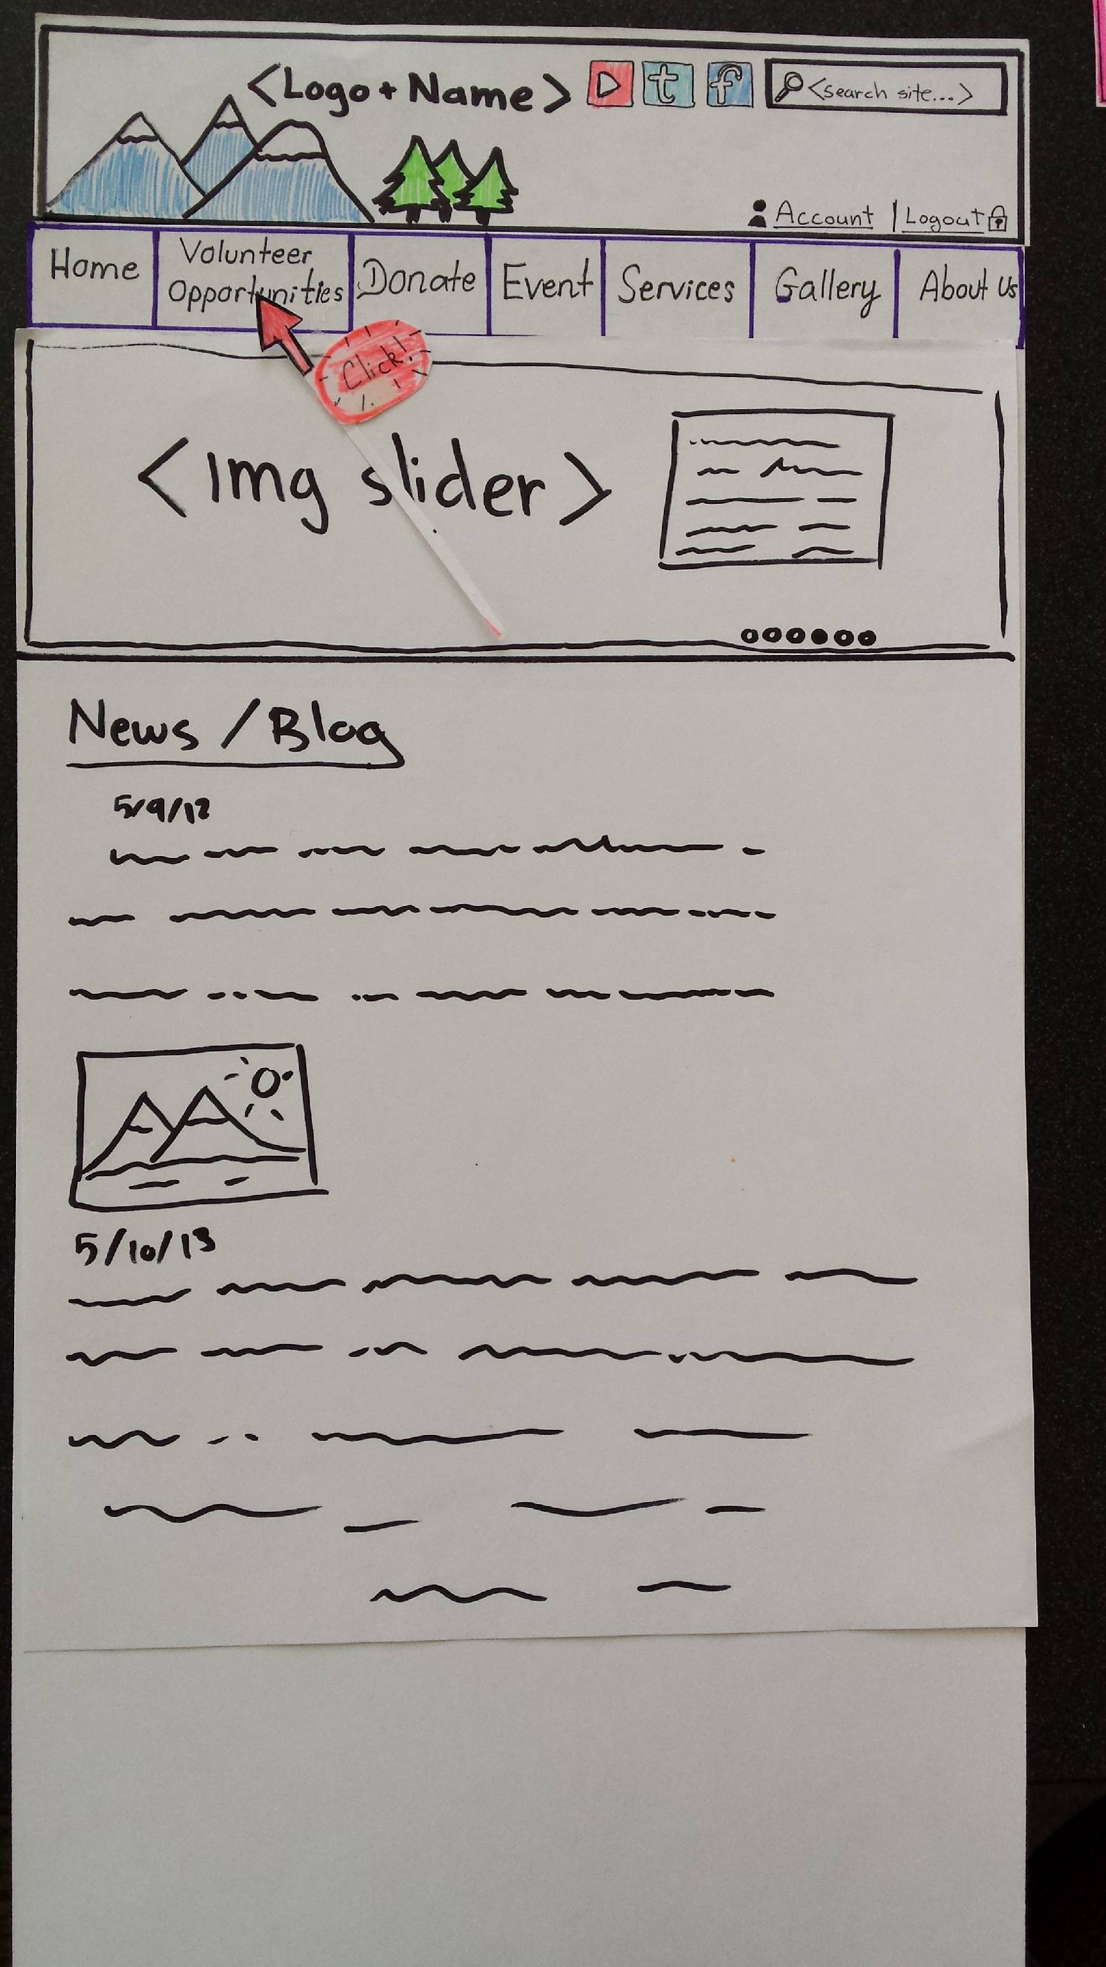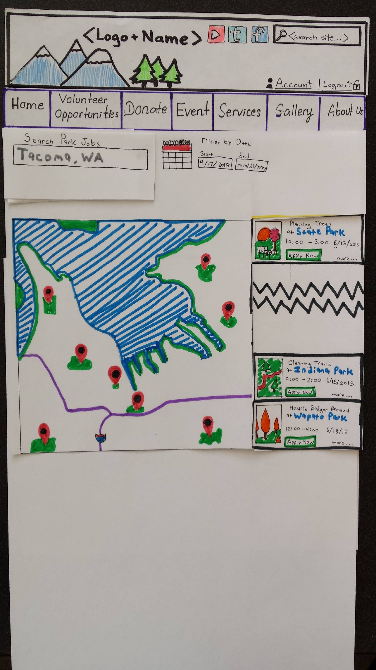

Figure 9

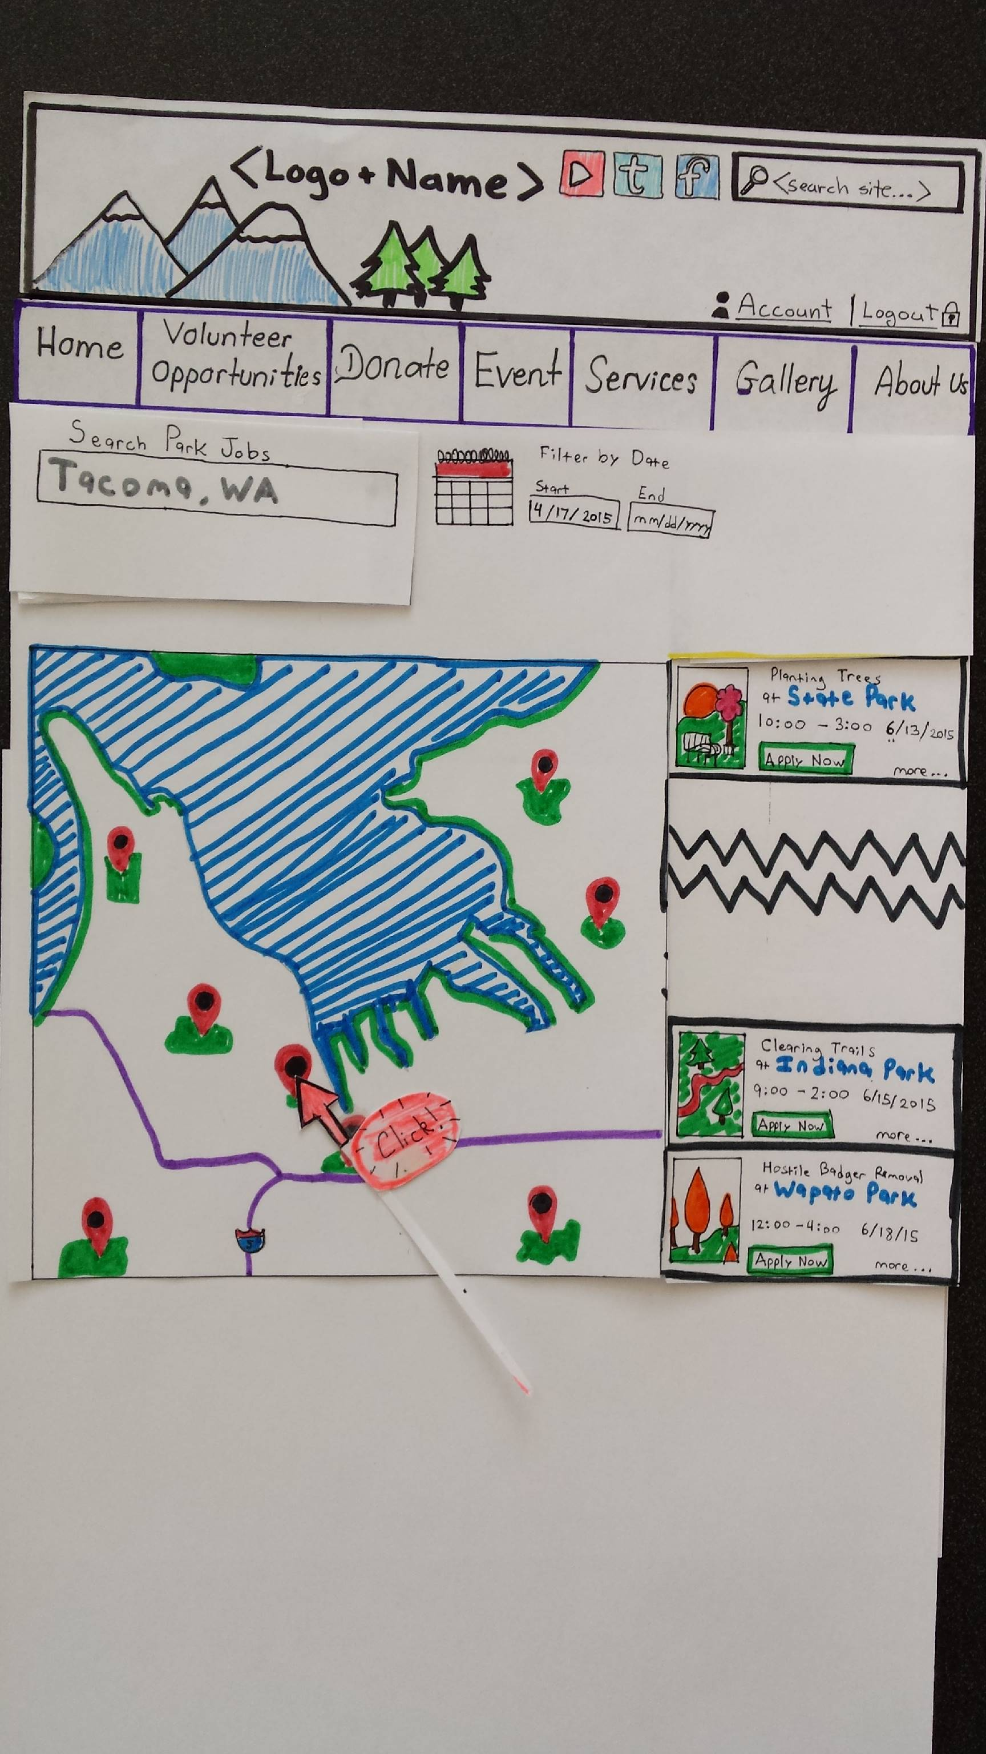

Figure 10

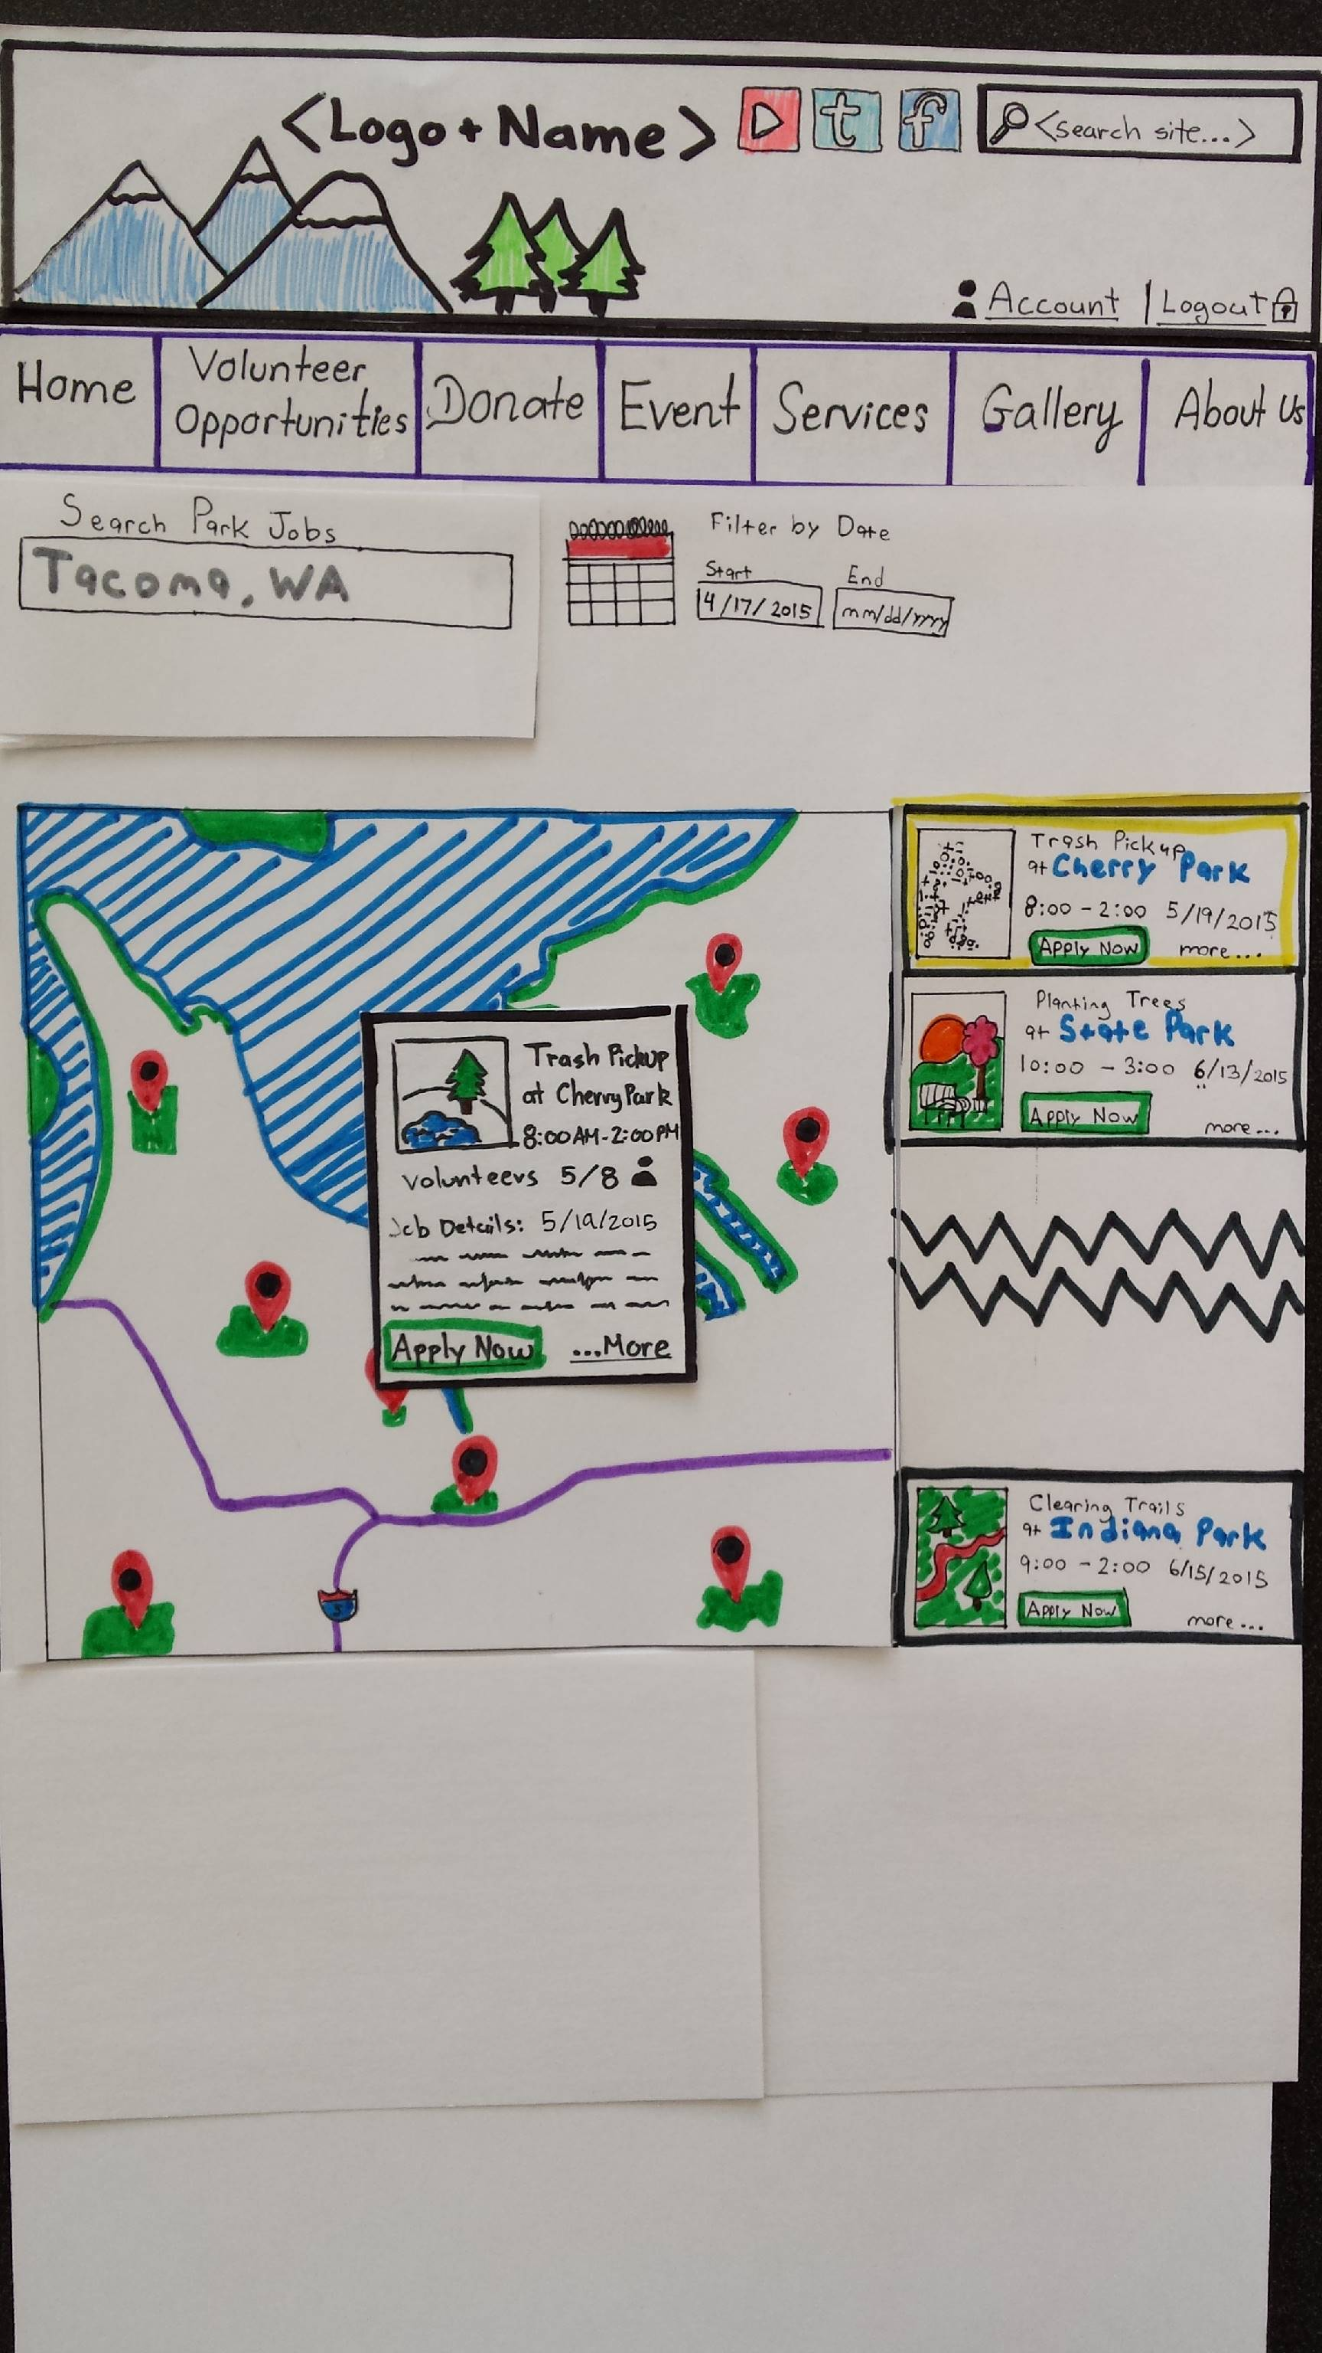

Figure 11

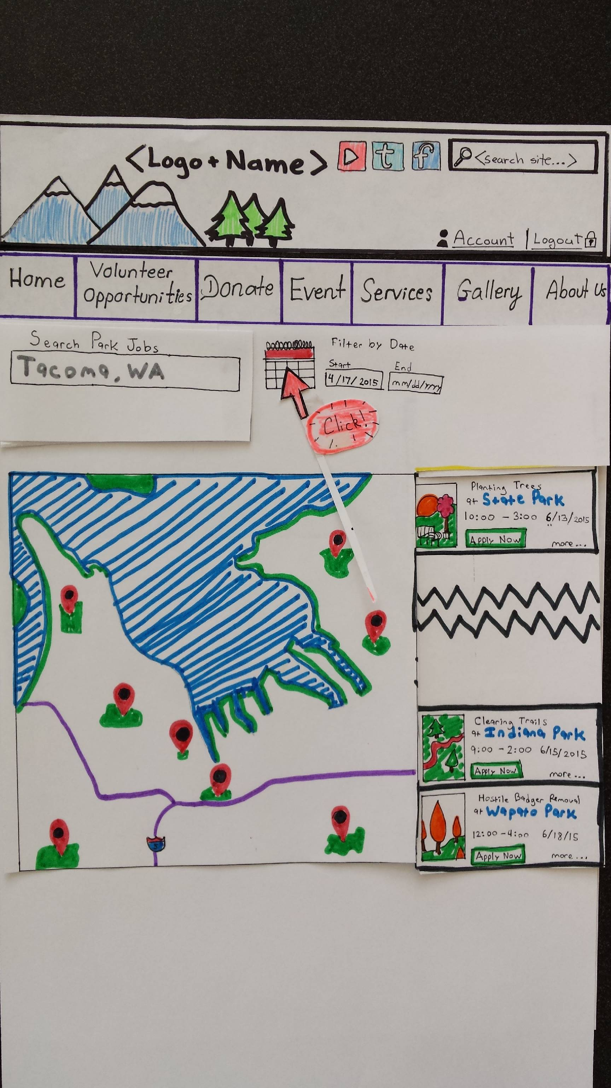

Figure 12

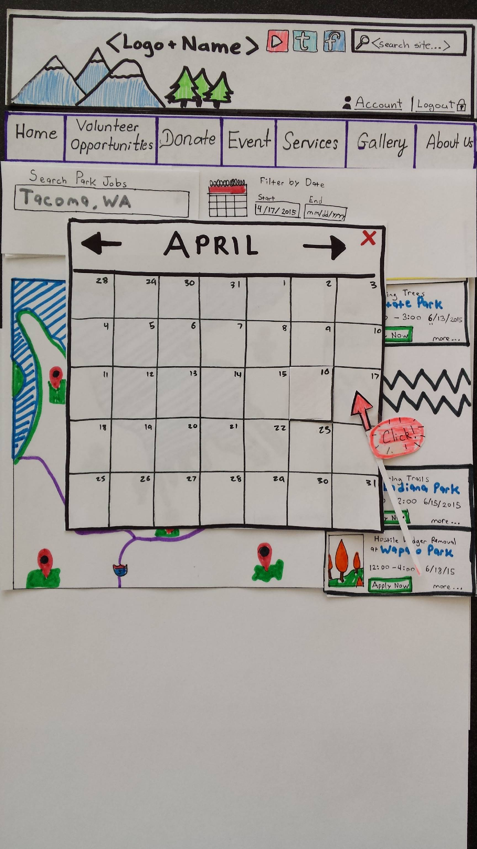

Figure 13

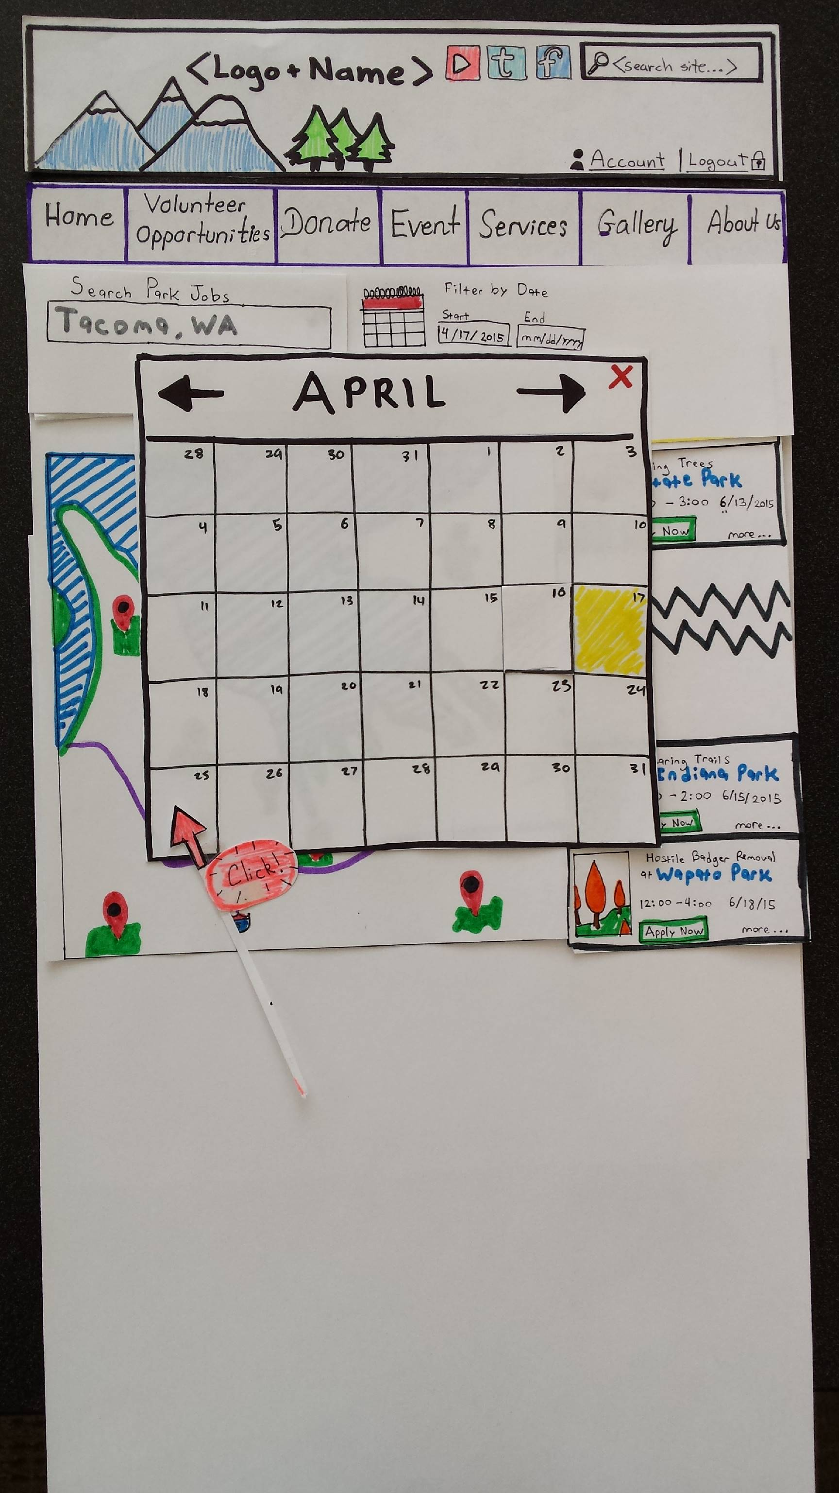

Figure 14

Figure 15

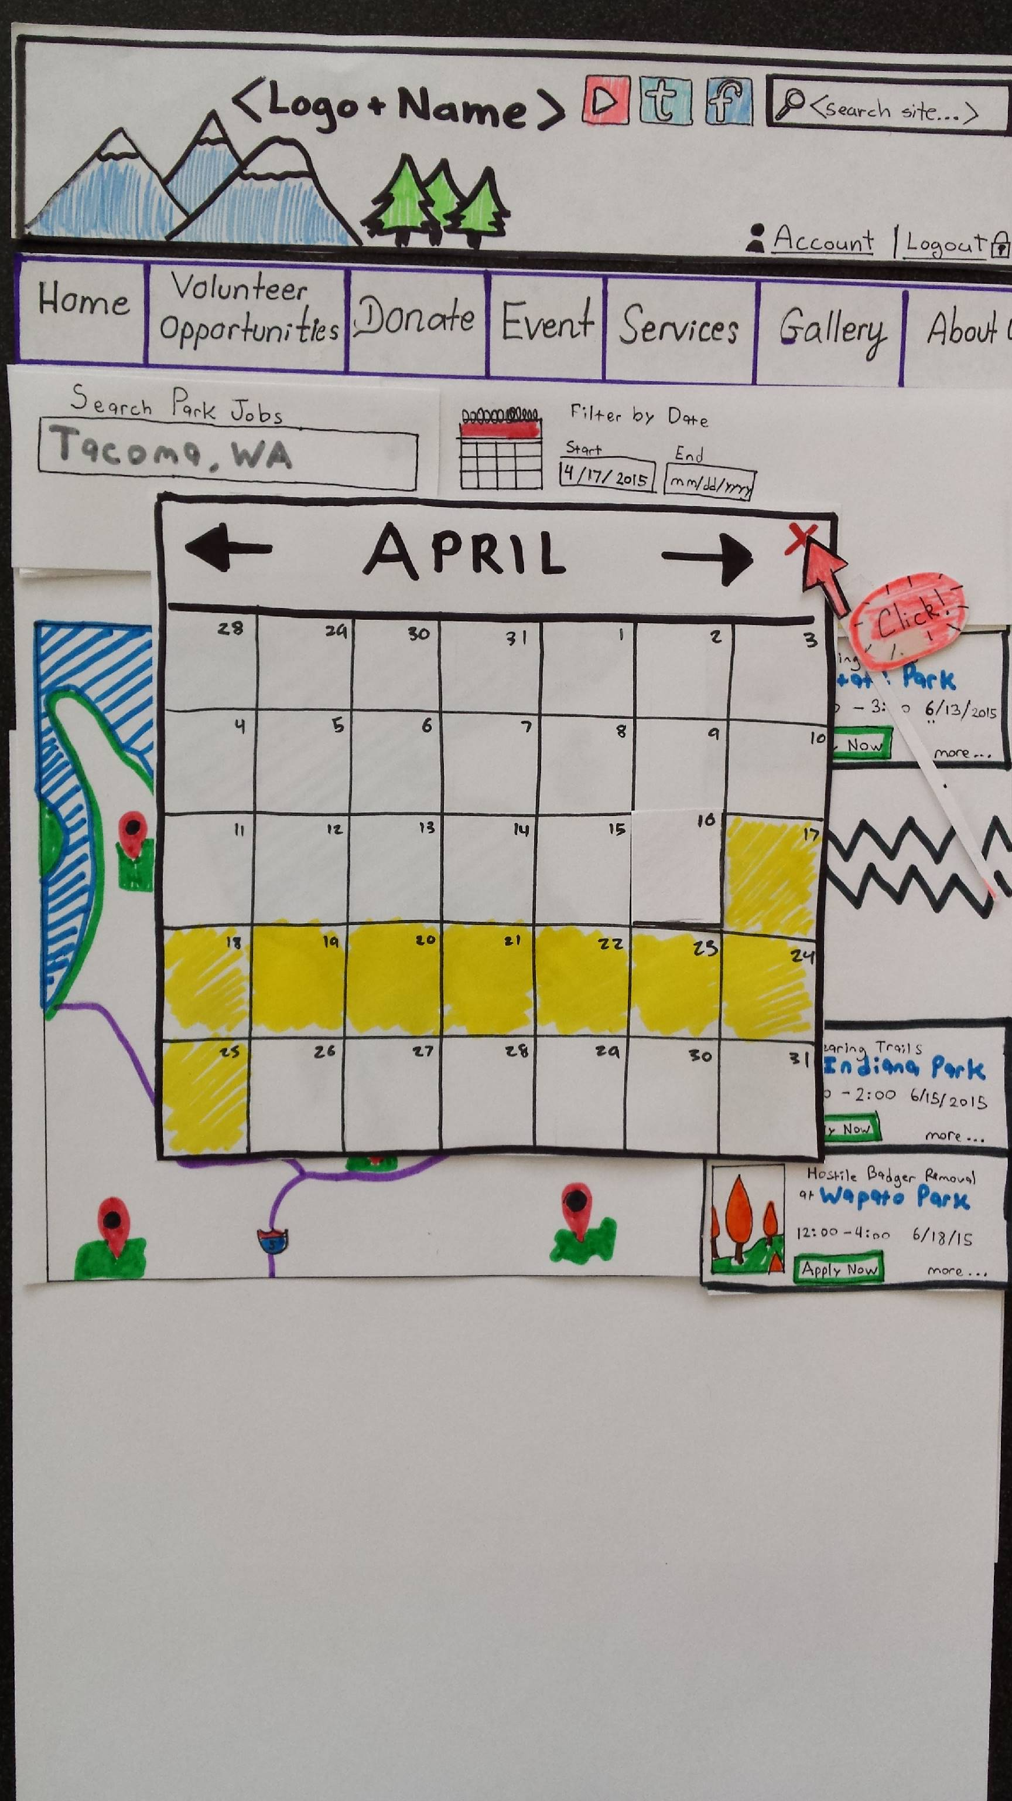

Figure 16

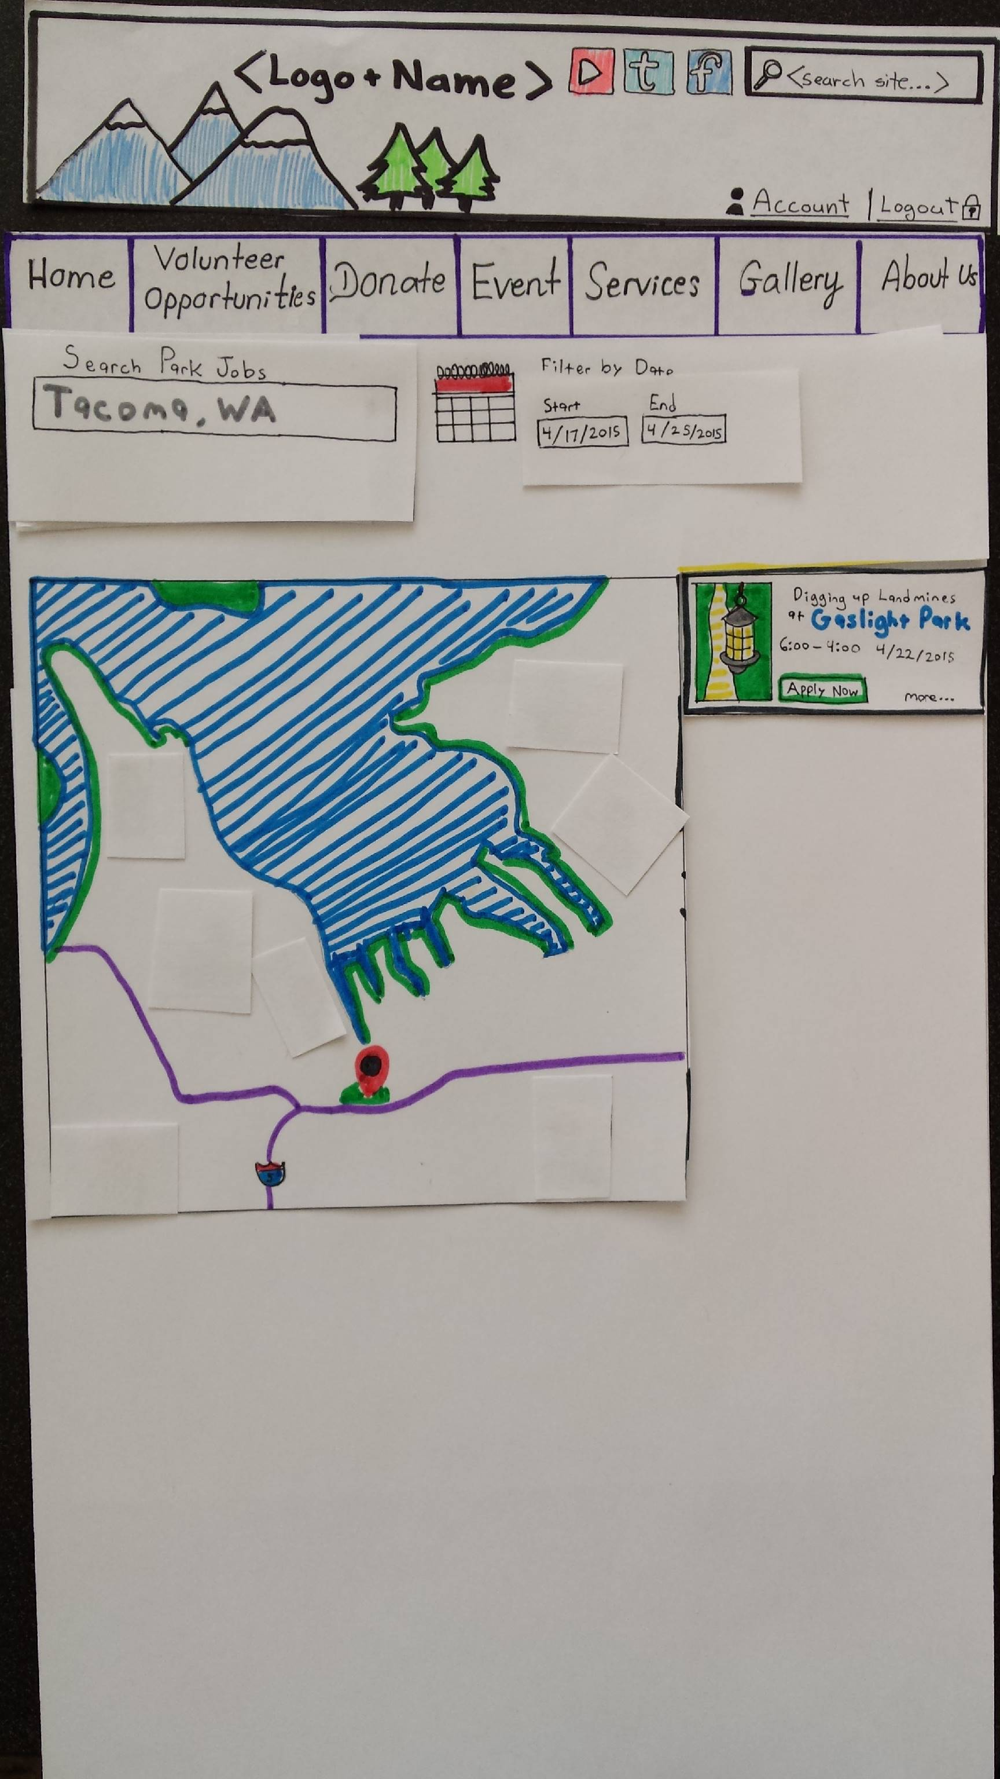

**As a volunteer, I want to sign up for a park job so that I can volunteer.**

Figure 17

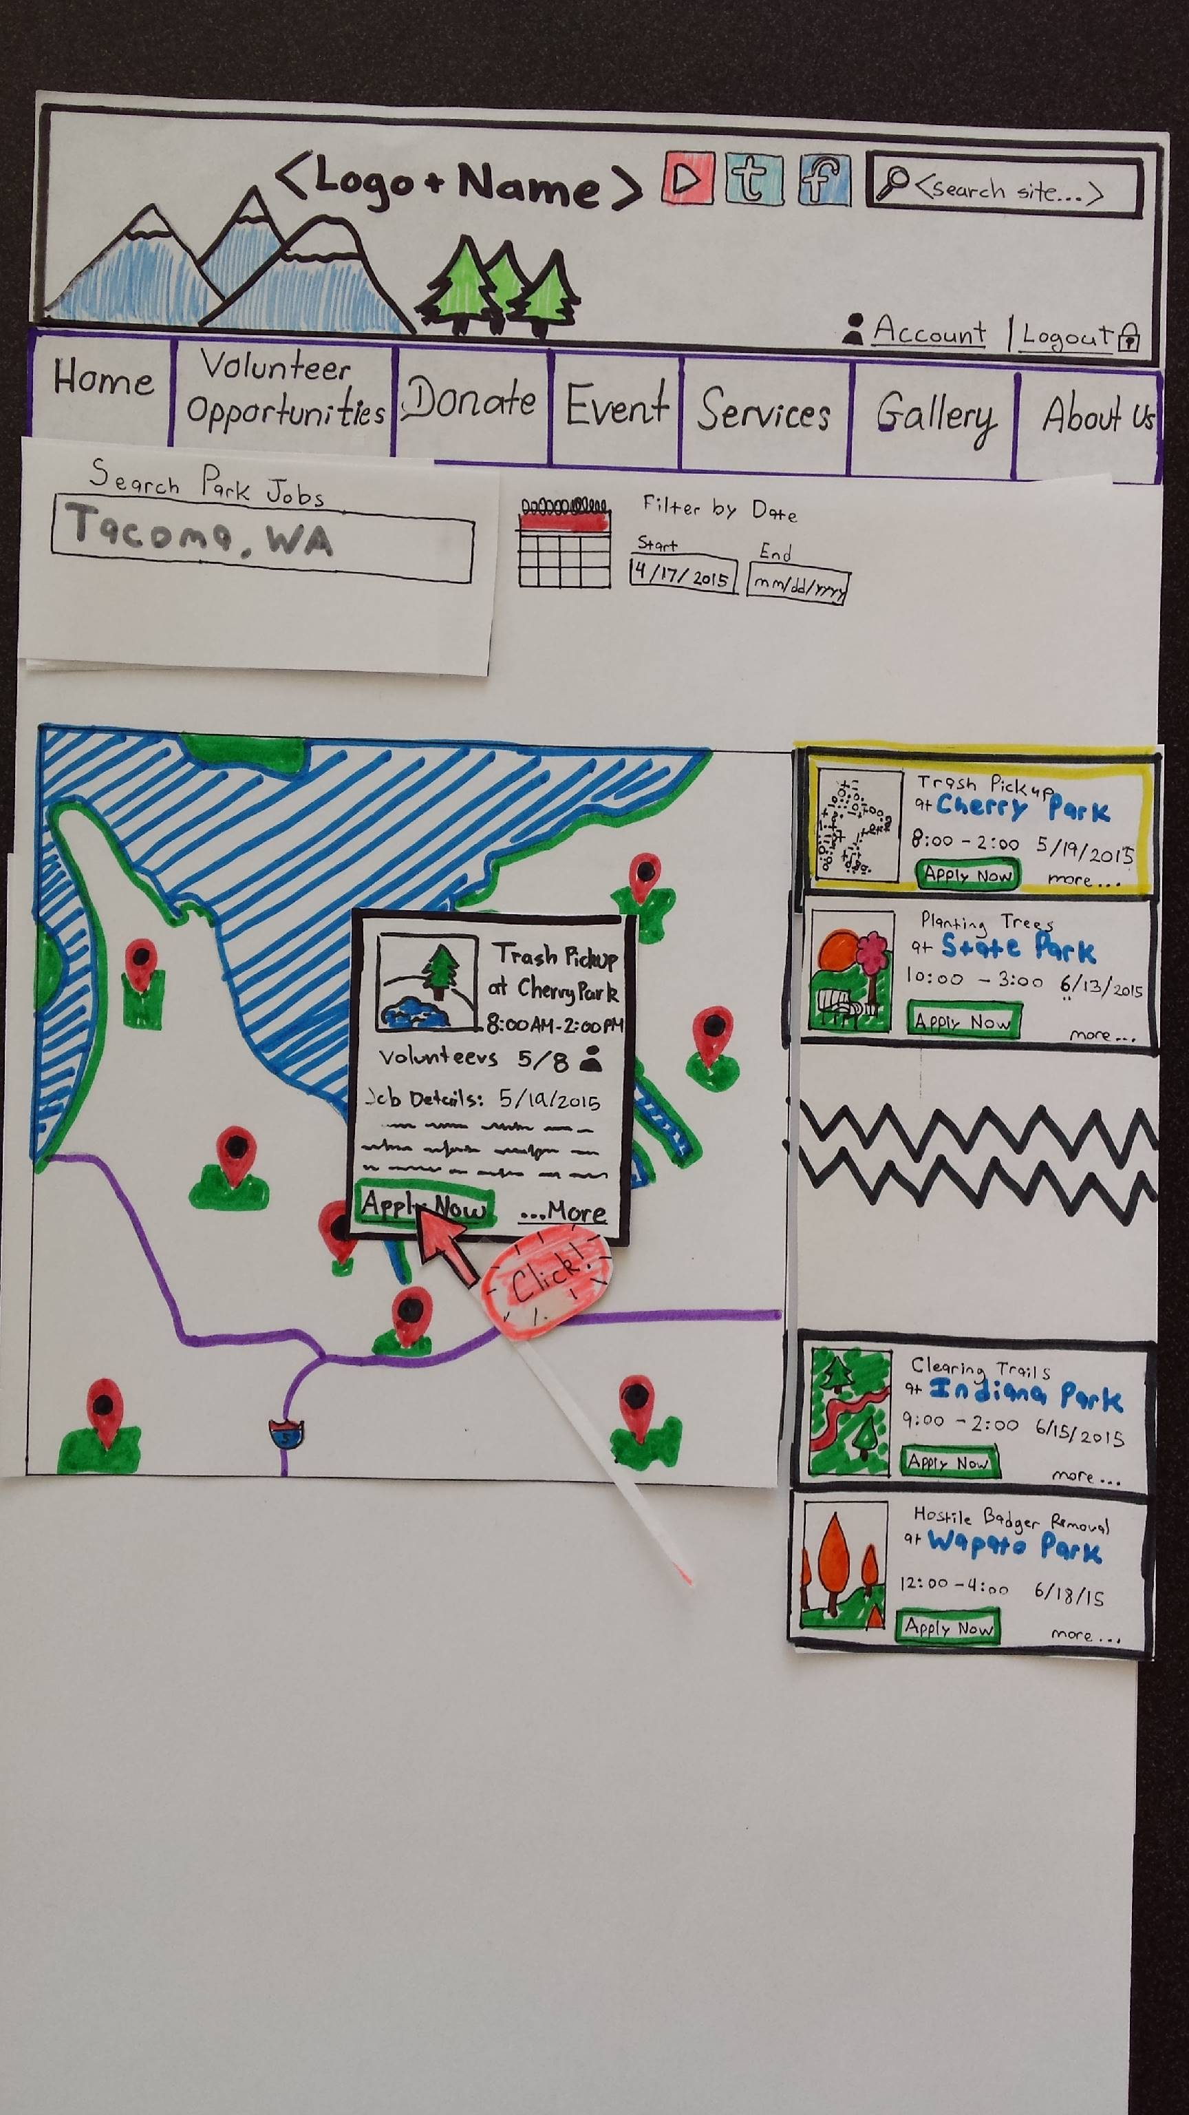

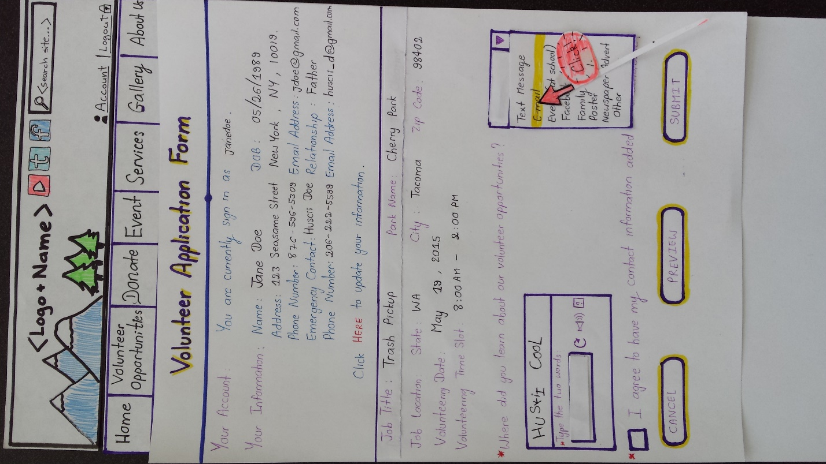

Figure 18

Figure 19

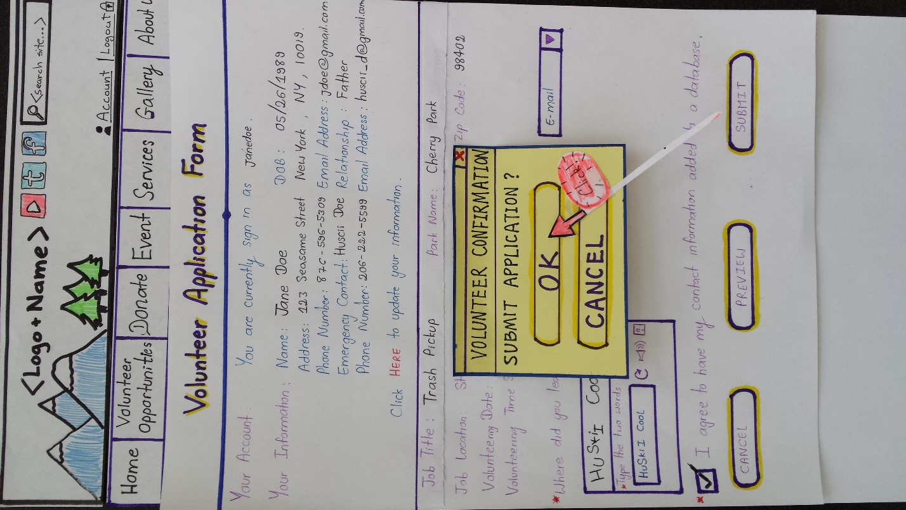

Figure 20

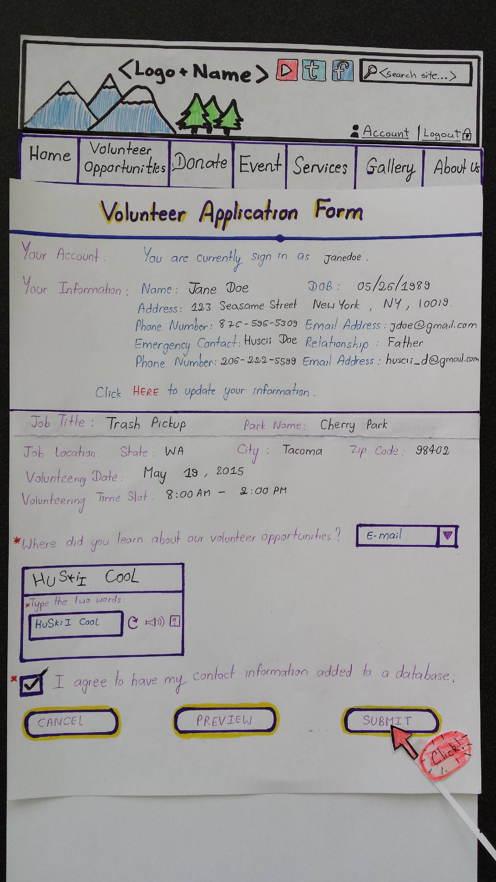

Figure 21

Figure 22

**As office staff, I want to view all pending jobs so that I know of future park jobs.**

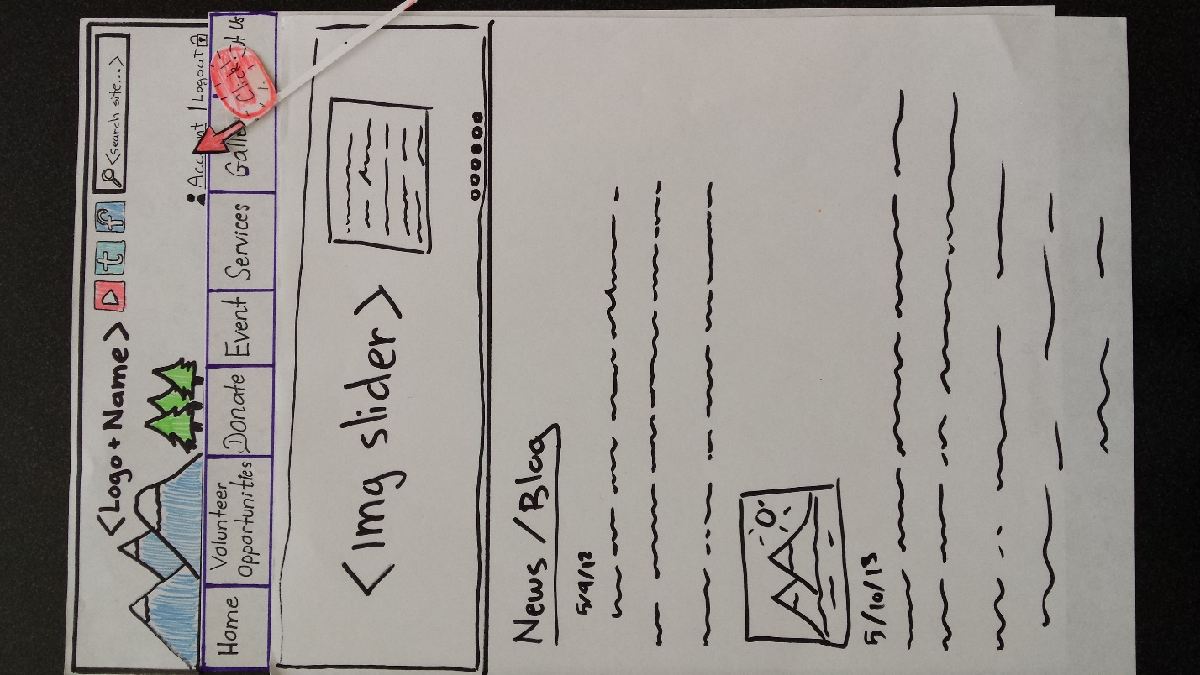

Figure 23

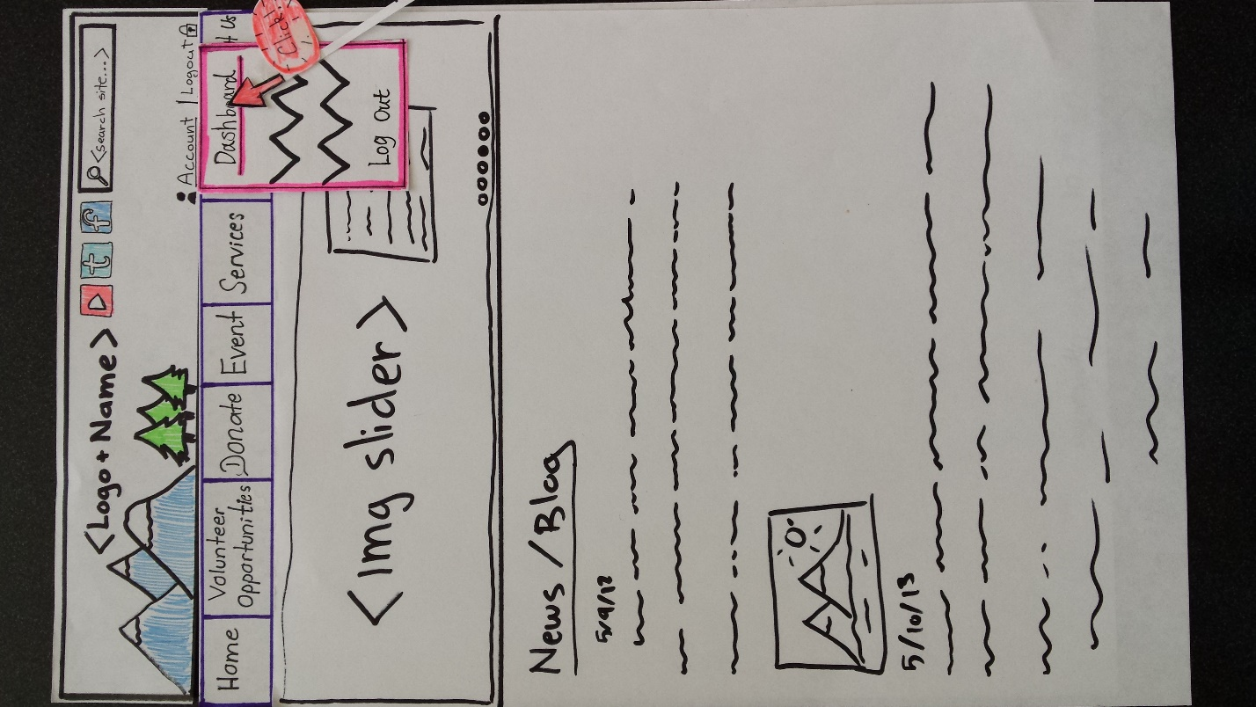

Figure 24

Figure 25